Squid – general setting

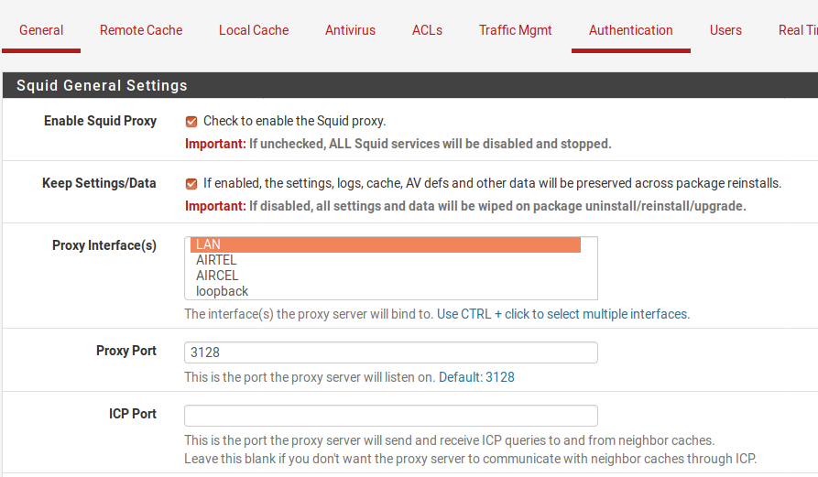

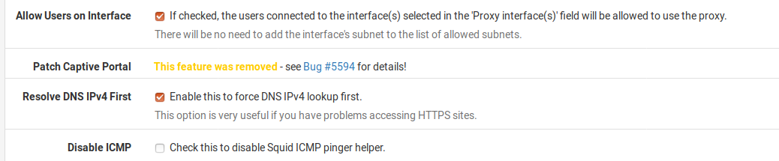

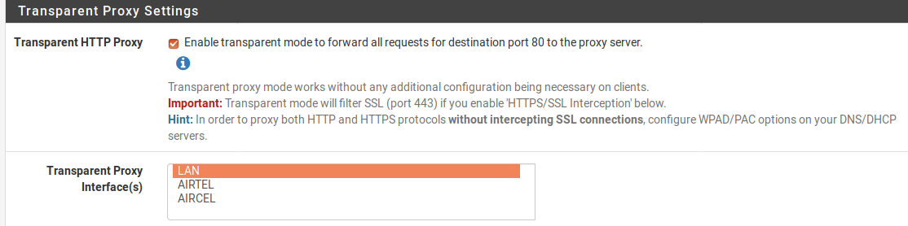
if you are using manual proxy then check transparent proxy settings

che
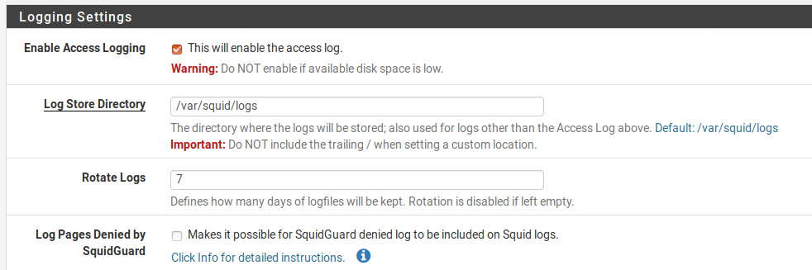

local cache- Hard Disk Cache Size – 1024

Service – squid gard proxy filter--

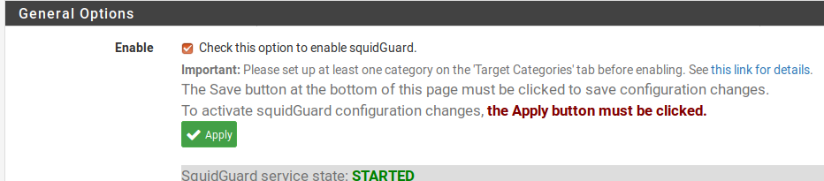

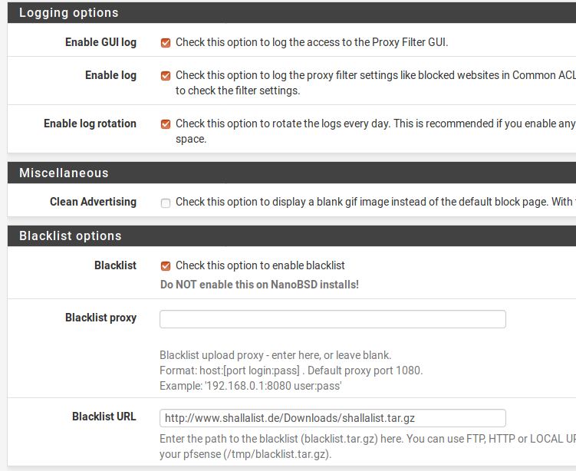

download blacklist – shallalist

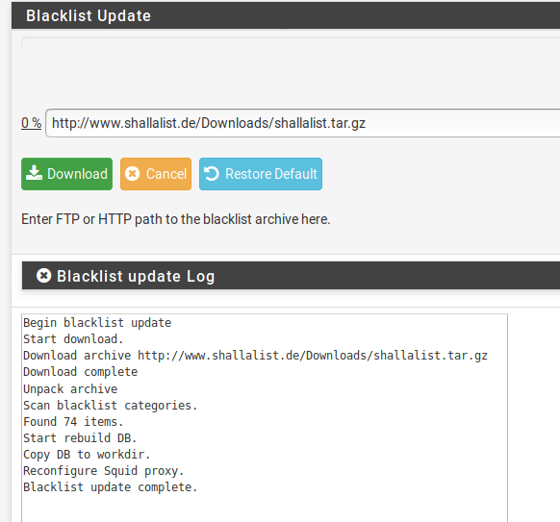

Proxy filter squidgaurd – target categaries --

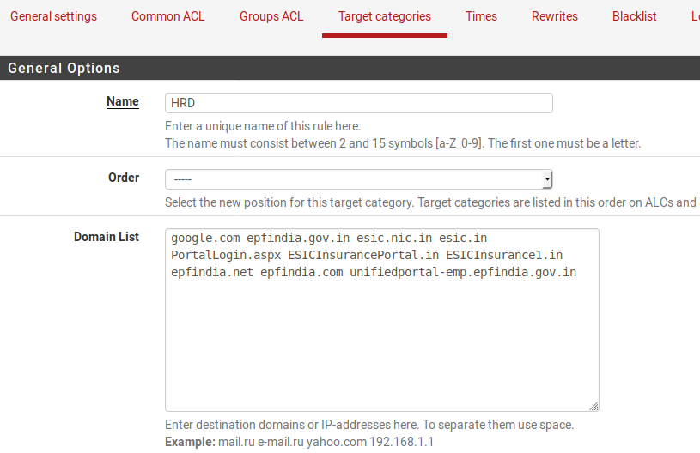

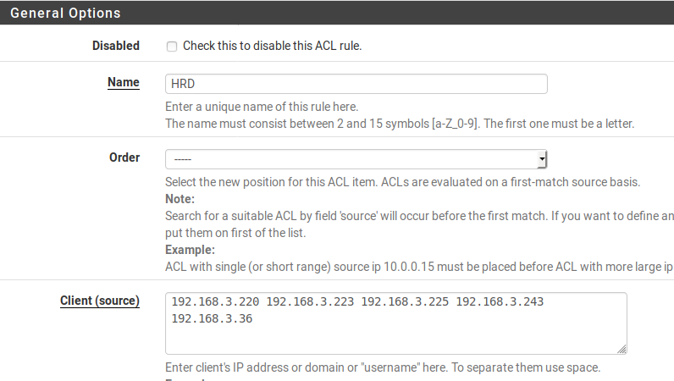
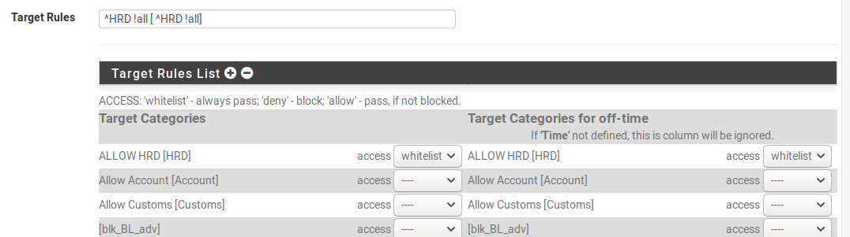

common acl – allow all default ----------

general stting – enable

